Game Design Document
Lizard Shot VR
Trello Link: https://trello.com/b/6abb865d7935ebc765ff5331
• | Genre: | VR Arcade Shooter.
• | Platform: | Virtual Reality.
• | Engine: | Unity 6.
• | Perspective: | First-person VR.
• | Target Audience: | 7–12 years, 14–20 years.
• | Players: | Singleplayer.

Game Concept
Lizard Shot VR is a fast-paced and accessible VR arcade shooter inspired by games such as Chicken Shoot and Chicken Riot.
The player finds themselves in a humorous environment filled with chickens. Using VR controllers, the player holds a virtual weapon and shoots chickens as they appear around the environment.
Unlike traditional arcade shooters, the player is physically inside the game world. The player can look around freely using the VR headset, meaning lizards can appear in front of, besides, or behind the player.
The main objective is simple:
Shoot as many lizards as possible before they escape or the timer runs out.
The game focuses on quick reactions, simple controls, humorous visuals and an accessible VR experience.
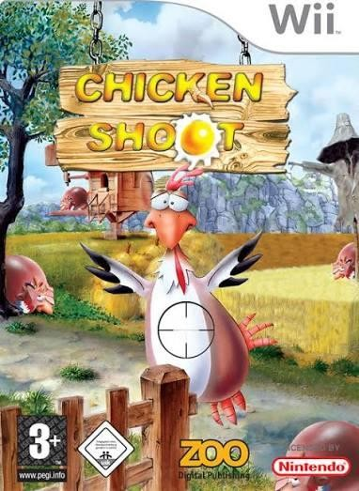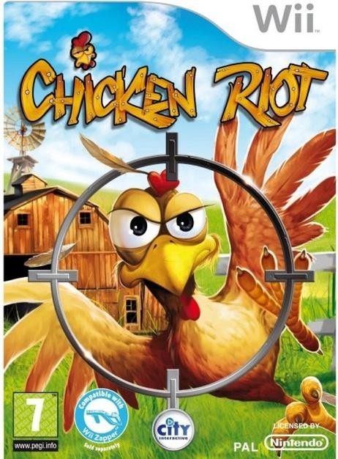

Core Gameplay
The gameplay is designed around a simple arcade gameplay loop:
- The player starts a round.
- Chickens spawn around the environment.
- The player looks around and searches for chickens.
- The player aims the weapon using a VR controller.
- The player pulls the trigger to shoot.
- Successfully hitting a chicken gives the player points.
- Chickens eventually disappear, escape or are replaced by new chickens.
- The game becomes progressively faster and more challenging.
- The round ends when the timer reaches zero.
- The player receives their final score.
The game should be easy to understand within the first few seconds of playing.
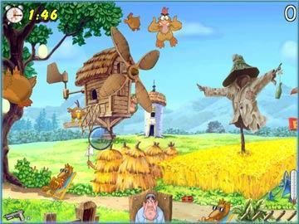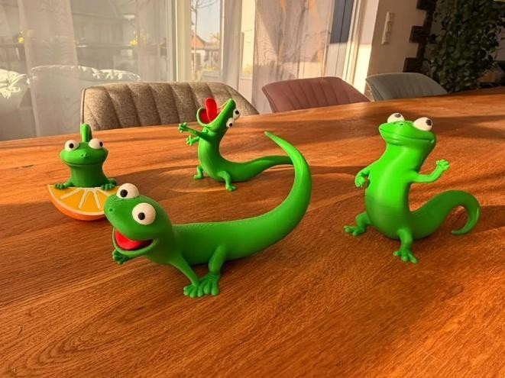

Game Objective
The primary objective is to achieve the highest possible score.
Players receive points for successfully shooting lizards.
- Shooting lizards quickly.
- Hitting multiple lizards in a row.
- Completing a round without missing too many shots.
- Shooting special lizards.
- Achieving a high combo.
- Beat the player's previous high score.
The game does not require complicated progression systems. The main motivation is improving the player's score and reaction time.

Target Audience
The game is designed primarily for two groups.
Children – 7 to 12 years The game should be:
- Easy to understand.
- Easy to control.
- Visually clear.
- Humorous.
- Not overly violent.
- Suitable for short play sessions. Teenagers and Young Adults – 14 to 20 years This audience may be interested because of:
- VR gaming.
- Arcade shooters.
- Fast gameplay.
- Competitive high scores.
- Humour.
- Nostalgia for games such as Chicken Shoot.


Inspiration
Chicken Shoot
Chicken Shoot is an arcade shooting game where the player shoots chickens that appear on screen.
The main inspiration taken from Chicken Shoot is its:
- Simple gameplay.
- Accessible controls.
- Chicken based theme.
- Arcade structure.
- Focus on achieving a high score.
Chicken Riot
Chicken Riot is another arcade shooter based around shooting chickens.
The main inspiration taken from Chicken Riot is:
- Fast paced gameplay.
- Moving targets.
- Quick reactions.
- Point and shoot gameplay.
- Multiple chickens appearing around the player.
The new game adapts these ideas specifically for VR.

Unique Selling Point
The main difference between this game and traditional “chicken shooting” arcade games is virtual reality.
The player can look around using the VR headset.
A chicken could appear behind the player. The player must physically turn around, aim and shoot it.
This creates a stronger feeling of being inside the game world.

